**Using the TV**

**For the DVD Player:**

1. Turn the DVD Player on using this button
2. Turn the TV on by pressing the power button on the TV remote control
3. Change the channel by pressing the source button on the TV remote control
4. Use the directional arrow buttons to select ‘HDMI1’ and press ‘OK’
5. Use the action buttons on the DVD remote to play the DVD
6. Use the + and - buttons to adjust the volume on the TV Remote

**For the computer:**

1. Turn the computer on
2. Turn the TV on by pressing the

power button on the TV remote

control

1. Change the channel by pressing the source button on the TV remote control
2. Use the directional arrow

buttons to select ‘VGA’ and

press ‘OK’

1. Log onto the computer as normal
2. Use the + and - buttons to adjust the volume on the TV Remote

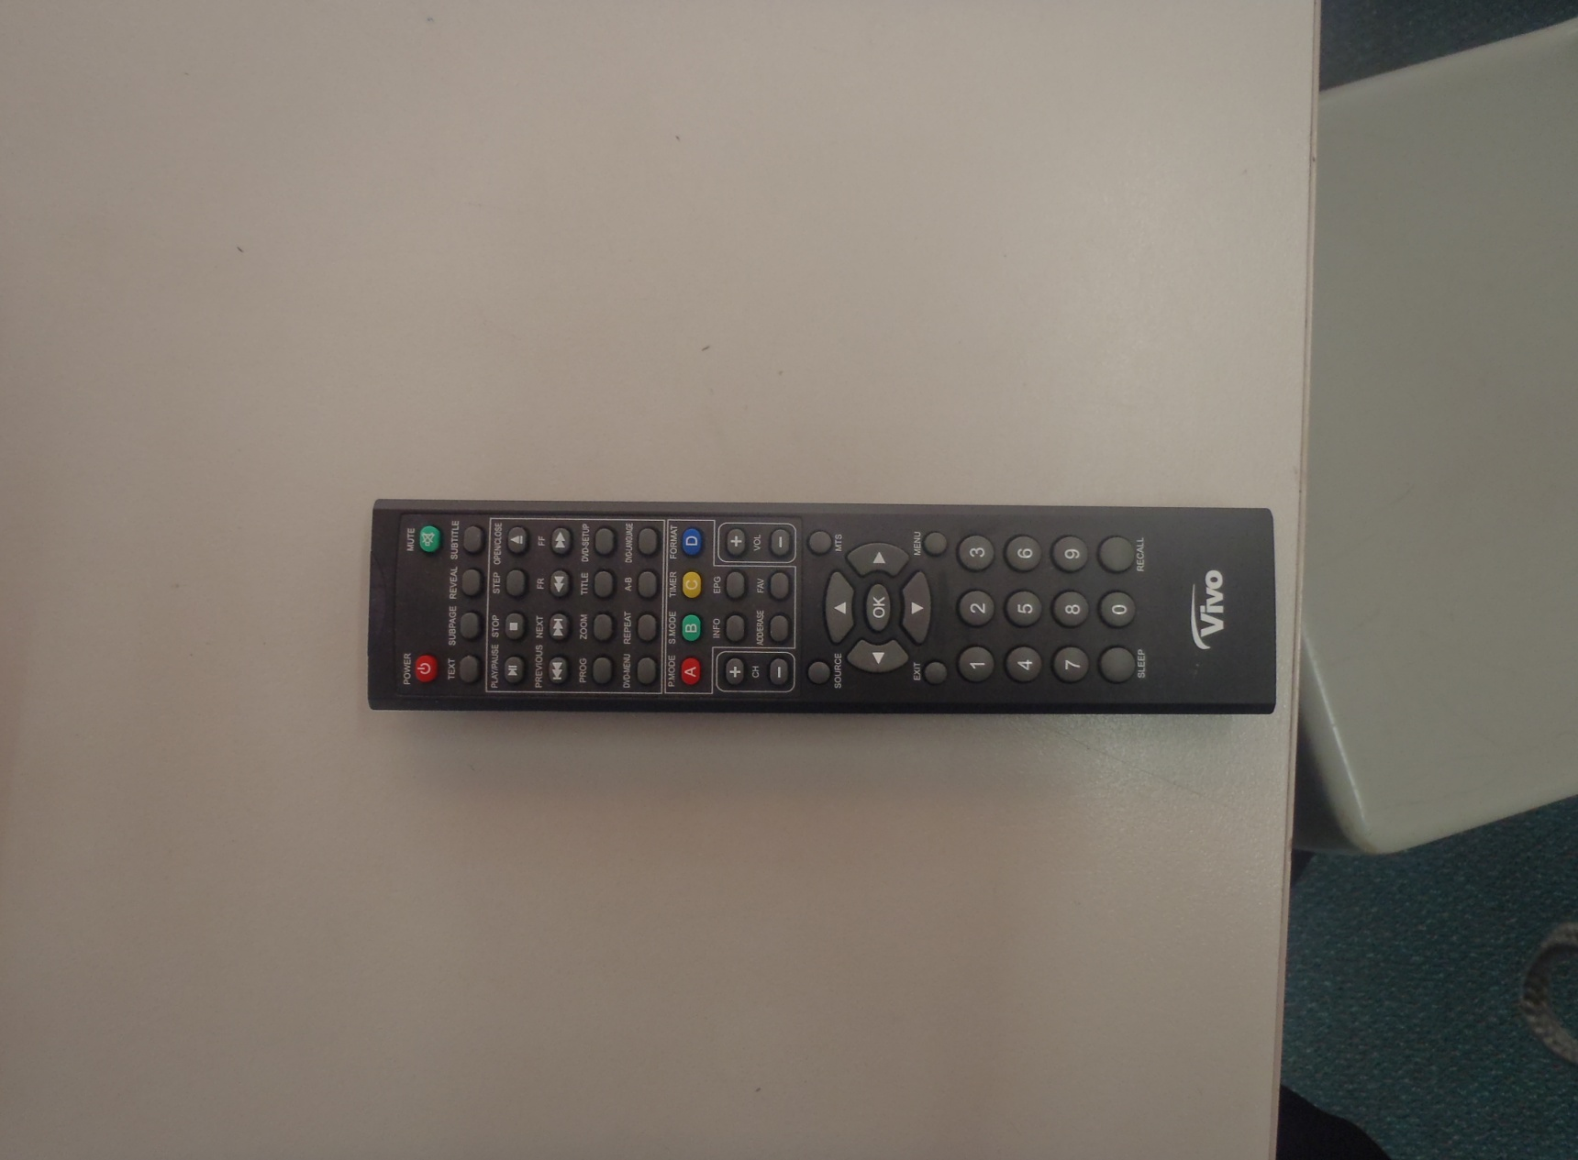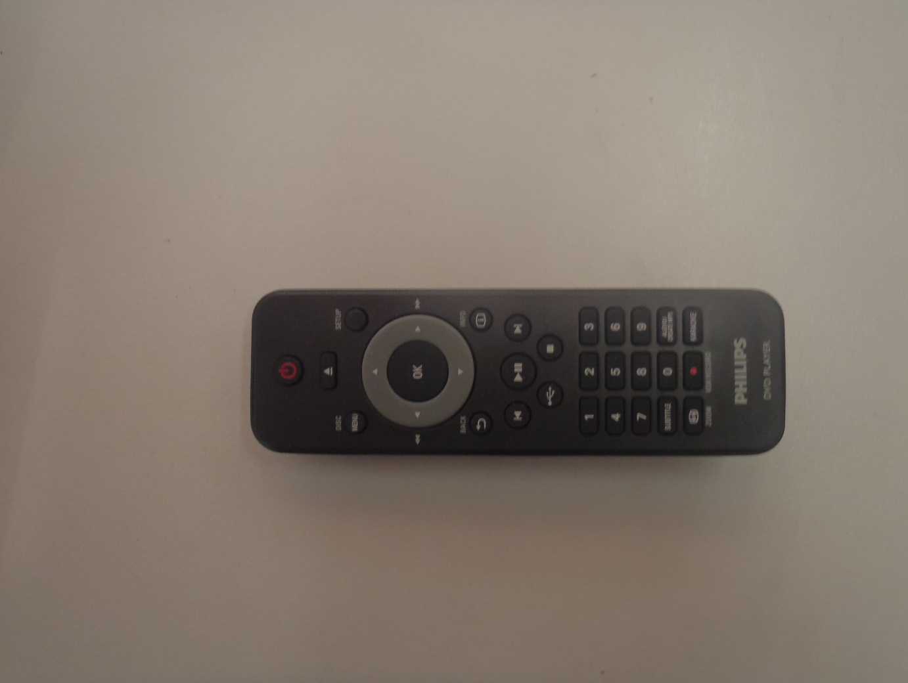

**DVD Remote**

**TV Remote**